**Assignment 2.2**

1. **The Typescript file:**

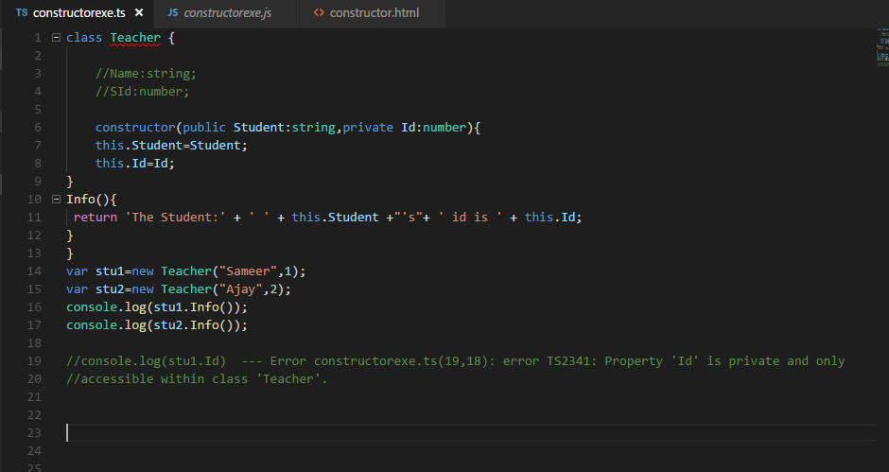

1. **Constructor.html file**

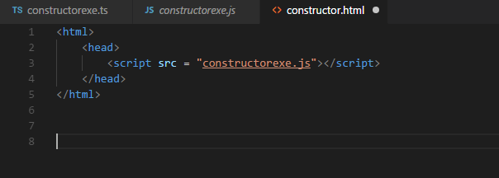

1. **Output**

**Output- @CMD**

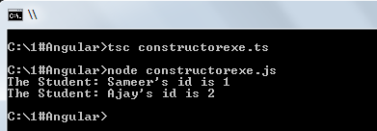

**Output- @Browser**

**file:///C:/1%23Angular/constructor.html**

